

2009 MEDIA KIT

88 varieties of hedonism.
That breaks down to 16 parts indulgence,
25 parts pampering and 47 parts sheer, unadulterated bliss.
Mix them all together, and you get
Wild Woozle body treatments, scrubs, lotions, soaps, & massage oils.
Hand-crafted tropical spa products to soothe your mind, body and spirit.

We'll take you there.TM

Contact

Daria Ross
Phone: 206.200.3491
Fax: 206.339.5296
info@wildwoozle.com
www.wildwoozle.com
Port Orchard, Washington USA

About Wild Woozle Soap Company

Wild Woozle Soap Company creates temptation in the form of luxurious, tropical bath and body products for home and spa, crafted with inspiration from the rich cultures of the Pacific, to add a little unadulterated bliss to daily necessities.

Our decadent and delicious smelling potions combine traditional, natural ingredients and fragrances from Tahiti, Hawaii, and around the world with our unique, modern delivery and a sassy twist.

About The Products

Wild Woozle offers a wide variety of tropical body treats for home and professional use, from hair to toes and all the parts in between. We collect the most luxurious ingredients nature has to offer and create our unique collection of high-quality, exotic and effective products.

Our hand-blended products are available in treatments and retail in select destination spas, day spas, salons, and boutiques across the United States, Europe, the United Kingdom, and, of course, online.

Product images, ingredient lists, and information are available upon request.

Our tribute to the allure of the South Seas is the South Pacific Collection, featuring our award-winning, genuine Monoi de Tahiti massage oil, sugar scrub, Dead Sea mud body wrap, massage bar, soap, hair pomade, and fizzy hydrotherapy bath powder. The seductive fragrance of Tahitian Gardenia is the heart of this exclusive mind and body therapy collection. | 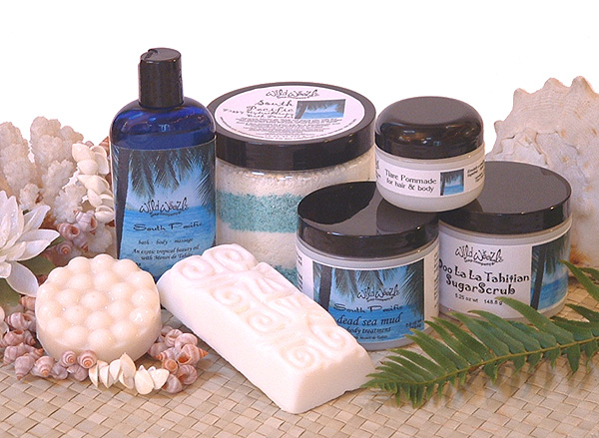

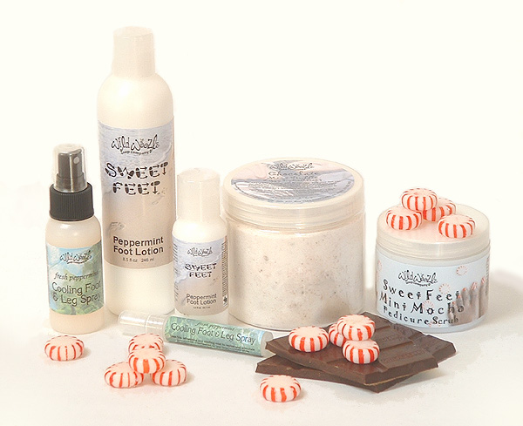 | Our professional treatment formulations include everything from complete body wrap systems to custom blended massage oils, all designed to induce bliss. We offer a variety of fragrance themes, including:  • Deep, Dark Chocolate Seduction,  • South Pacific Cocoon,  • Hawai’ian Honey Glow, and  • Tahitian Grapefruit Rejuvenation.

Our popular tropical pedicure and manicure experiences are available in unique fragrances, including:  • Margarita Beach Spa Pedicure,  • Mango Passion Spa Pedicure,  • Sweet & Spicy Pedicure Collection,  • Mint Mocha Pedicure Collection, and  • Onolicious Coco Mango Tropical Manicure | 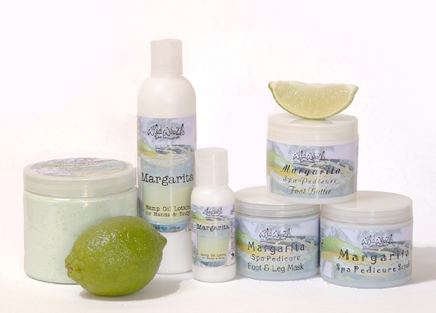

We offer a distinctive selection of exfoliating sugar scrubs, carefully formulated with a variety of nourishing oils, botanical extracts, and fragrances. Our hemp oil lotions, in complimentary scents, work in harmony to create an exceptional, stress-defying ritual for home or spa. These popular product lines can be mixed and matched for flexible menu options and offered for follow-up retail sales. | 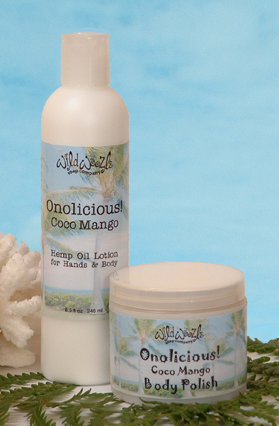

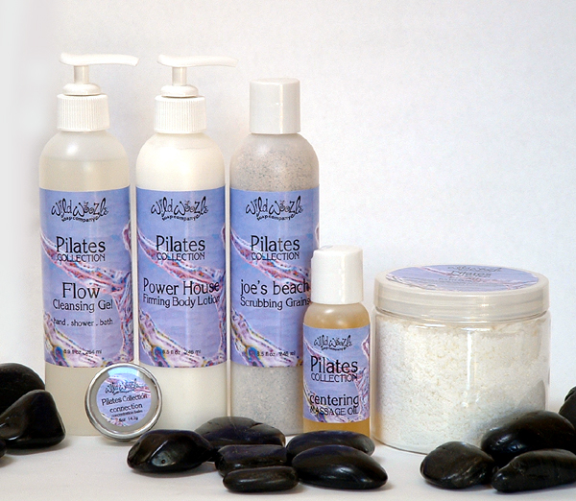 | The Pilates Spa Collection was specifically created to support and enhance the art of Pilates. This suite of meticulous skincare formulations was inspired by, and designed to enhance, the basic principles of Pilates. Shaped by the intersection of science and nature, this innovative skincare system uses a synthesis of cutting edge research and traditional, natural ingredients. This complete body care line is scented exclusively with select essential oils.

Sea of the Moon Skincare System is a collection of exceptional natural products designed to fight signs of aging and to protect and nourish the skin. A synergy of modern technology and traditional wisdom, crafted to combine precious and effective botanical actives with time-honored skincare ingredients from around the world. A complete and luxurious daily skincare ritual. | 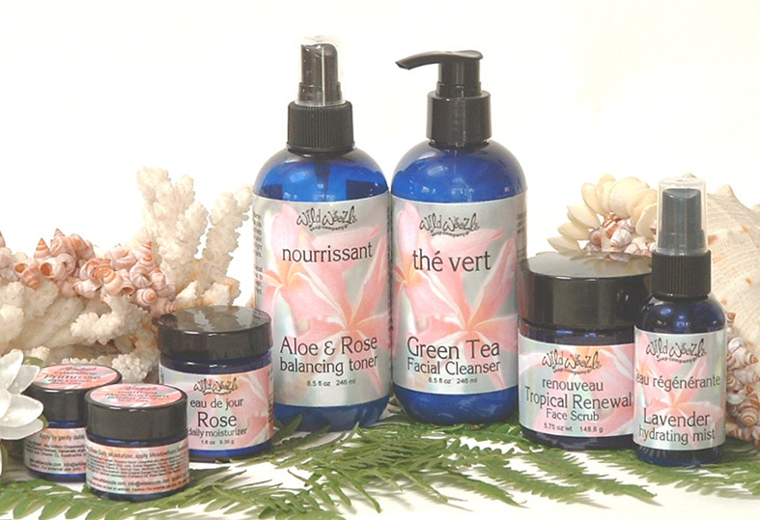

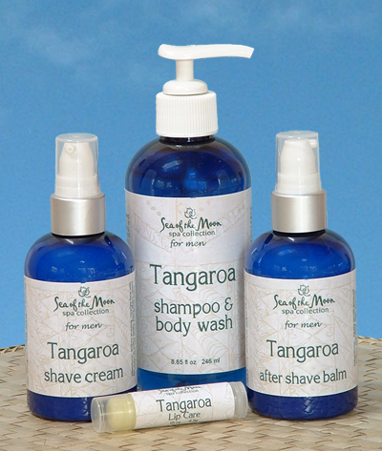 | Tangaroa Men's Skincare Collection  Our exclusive collection of natural aromatherapy-based products is specifically designed for men's skincare needs.  Inspired by traditional ingredients, modern botanical extracts, and the power of an enticing masculine fragrance, this line is precision formulated to meet the skincare needs of today's men. Products include shave cream, after shave balm, shampoo and body wash, and lip balm.

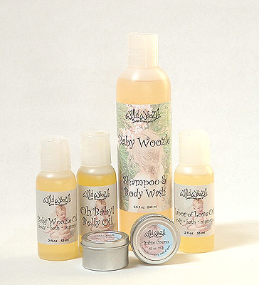 | We offer several distinctive collections, including the Lotus Yoga Collection, Baby Woozle for baby and new mother care, and Surfer Chick hair and body products.

About Our Philosophy

Despite our whimsical nature, Wild Woozle takes a few things very seriously. We believe in:

- Products that are individually hand-crafted to ensure freshness and to meet our high quality expectations. We offer over 160 products; almost 60% of them are completely preservative free. In those products where we must use a preservative, it is paraben-free and a non-formaldehyde donor.
- Customer service with a passion. We offer a no-questions-asked satisfaction guarantee, free shipping on orders over $75, product samples with every order, personal responses to every email and phone call, free gift cards and optional gift wrapping.
- No animal testing. We don't buy materials from suppliers who test on animals, nor do we ask anyone to do animal testing on our behalf. Most of our products are also certified vegan.
- Being part of our community. We regularly make product and monetary donations to local, national, and international organizations related to women's shelters, children's aid, hunger relief, cancer research, and natural disaster relief. Through our support of these issues, we strive to set an example for business leadership and social involvement.
- Responsibility for our planet. Our ingredients are thoroughly researched and responsibly sourced. We are meticulous about recycling, from office to warehouse. Based on our social responsibility and green business practices, we have been accepted for membership in Co-op America, a group of green businesses and progressive business leaders working to solve social and environmental problems.
- Truth in labeling. No misleading fluff and hype. We are members of the Natural Ingredient Resource Center, which established guidelines for natural product labeling.

About Daria Ross  Wild Woozle Soap Company's founder, Daria Ross, has pursued the study of natural skincare and alternative paths to wellness, particularly through aromatherapy and traditional Polynesian beauty and healthcare customs. With that knowledge and a combination of passion, obsession, dedication to quality and personal customer service, and an irreverent sense of humor, she created what is now the internationally known Wild Woozle Soap Company®. | 

